**Report Business Intelligence: Analysis of Supermarket Sale**

**Title: Analysis of Supermarket Sales  
Isaac Afedia  
N01513981**

**Introduction:**

This report presents an in-depth analysis and insight into supermarket sales within 3 cities where a prominent supermarket company operates. The dataset under examination comprises 18 features and 1000 instances, encompassing critical information such as Invoice ID, Branch, City, Customer Type, Gender, Product Line, Unit Price, Quantity, Tax (5%), Total Amount, Date, Time, Payment Method, Cost of Goods Sold (COGS), Gross Margin Percentage, Gross Income, and Rating. The primary objective of this analysis is to extract insights into consumer behavior and market trends, empowering the supermarket company to make well-informed business decisions driven by data.

**Analysis and Findings:**

**Sales and Profit Distribution by Product Line:**  
A Stacked bar chart revealed that "Food and Beverage” and "Sports and travel" contribute significantly to sales and profit, indicating high demand in these product categories.

Insights: The company should focus on optimizing these two product lines further to harness their revenue potential.

**Average Monthly Sales of Each Product Line:**  
A highlight table demonstrated that *Home and Lifestyle* exhibits relatively consistent average monthly sales, implying stable consumer interest.

Significance: *Home and Lifestyle* could be considered a steady revenue stream, while adjustments may be needed for other product lines showing fluctuating averages.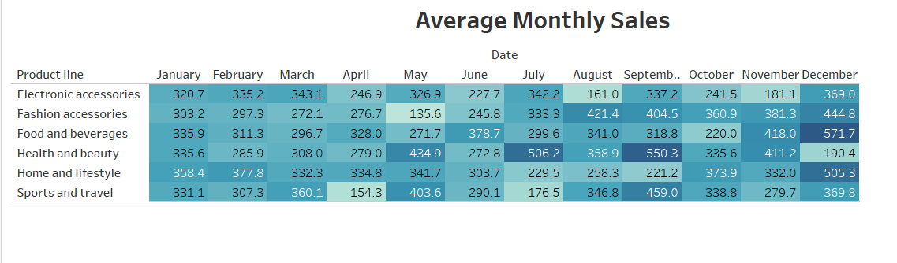

**Total Sales by Payment Method:**  
A pie chart unveiled that "Cash" is the preferred payment method, accounting for the largest portion of total sales.   
Impact: Emphasizing and improving the Ewallet experience could enhance customer satisfaction and drive higher sales.

**Total Sales by Branch for Each Month:**

Showed that there was a crash in sales between the months on March and April across all branches and also that branch C did a little better

Insights: Investigating the cause of the crash and also the practices and strategies of "Branch C" could provide valuable insights to enhance sales performance across all branches.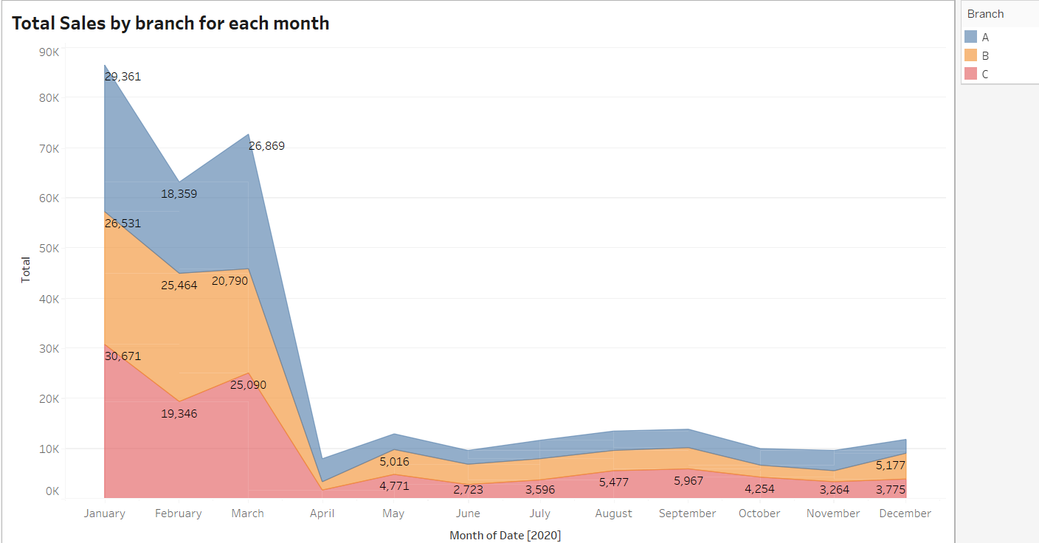

**Monthly Sales per Product Line:**A line chart demonstrated varying sales trends across different product lines, with "Sports" hitting the highest sales in January.

Importance: Monitoring these trends allows for resource allocation and inventory management aligned with changing customer preferences.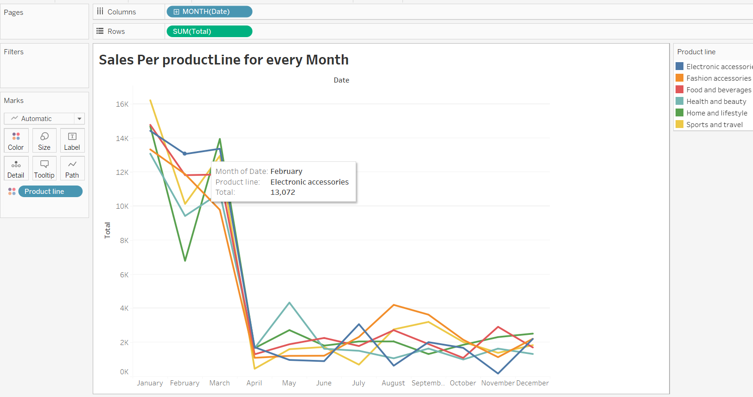

Conclusion and Recommendations:

This analysis of supermarket sales and consumer behavior offers key insights that can guide data-driven decision-making. The company should consider the following recommendations:

* Invest in the "Food and Beverage” and "Sports and travel" product lines to capitalize on their popularity.
* Leverage the appeal of "Home and lifestyle" as a steady revenue source.
* Enhance the Cash payment experience to further boost sales.
* Study "Branch C" to understand its successful strategies and replicate them across branches.
* Continuously track product-specific sales trends to optimize inventory and promotional strategies.
* Mostly, a thorough investigation should be conducted into the cause of the sales dip between March and April to provide a solution to remedy the situation and increase sales.

**Future Steps:**   
In future steps, the analysis could be extended to explore customer segmentation based on gender, customer type, and other factors. Additionally, sentiment analysis of customer ratings could provide deeper insights into customer satisfaction, payment method by city can also be done to give further insights.

Overall, this analysis equips the supermarket company with actionable insights to refine its sales strategies, enhance customer experiences, and thrive in the competitive retail landscape.